Troop 126

Intro to Snow Camping

February 28th - March 2nd, 2025
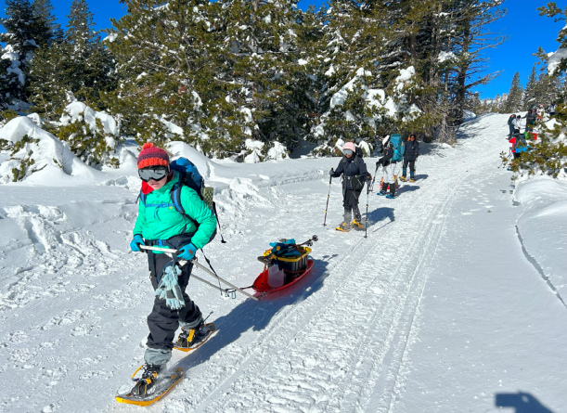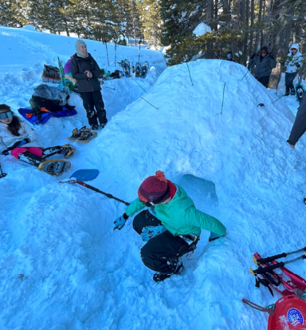
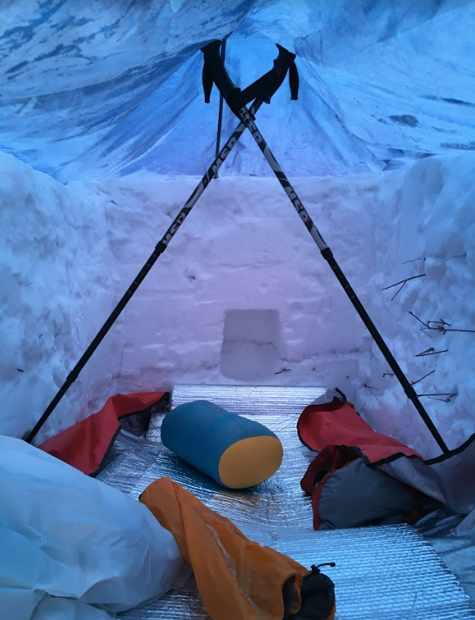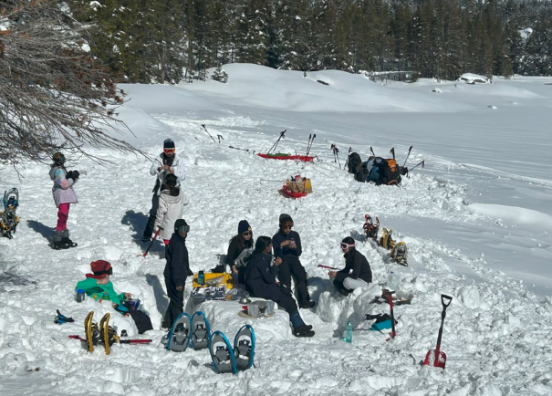

Last Updated: 1/7/2025. Special thanks to Wen Huang for the creation of the original version of this manual.

Overview
If weather permits, Troop 126 plans to have a two-night snow camping trip at Camp Hi-Sierra during the weekend of February 28, 2025 for the beginner level Okpik training.
Okpik is pronounced as (OOk`pick) in the Inuit language for snowy owl. It’s the cold-weather adventure program offered by the Boy Scouts of America. Intro to Snow Camping will be an introductory session to scout’s first-time experience of learning about snow camping before they advance to the Intermediate Snow Camping.
Scouts will leave for the destination Friday afternoon and lodge in cabins at Camp Hi-Sierra. The group will travel Saturday morning to the CA-108 Snow Park, build a snow kitchen for their Saturday lunch, go through 2 training stations for building snow cave and trench shelter in the afternoon and return to Camp Hi-Sierra for the night. We will head home Sunday morning.

Goals
- Introduction to snow camping’s preparation (Concept and gear) and implementation (snow caves, trench shelters, emergency shelters, cooking in snow, etc.).
- A one-hour snowshoe hike at Camp Hi-Sierra if field conditions allow.
- Nurture outdoor survival skills at high adventures in low-temperature winter conditions, e.g., avalanche and ice rescue.

Gear – For Intro Snow Camping Session
The below list is for the intro session since we are spending the night in cabins. The amount of clothing will increase if we eventually camp overnight in the snow.
- Personal gear
  - NO COTTON ON PERSONAL GEAR – COTTON KILLS HEAT WHEN IT GETS WET! (Check the content tags for synthetic fibers like polyester, nylon, spandex, etc.)

YOU CAN RENT MOST GEAR FROM SPORTS BASEMENT:
https://shop.sportsbasement.com/collections/snow-apparel-rentals
  - Head: 2 winter hats (balaclava, or beanie that can cover ears, etc.) in case one gets wet, scarf or neck gaiter
  - Sunglasses or ski goggles: With shade and anti-fog
  - Clothes and pants in layers from inside to outside:
    - Wicking layer: 1 pair of synthetic long underwear (tops and bottoms)
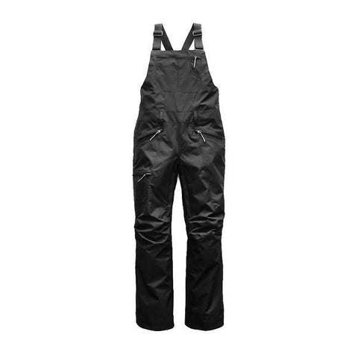
    - Warm insulation, 2 sweaters (Preferably wool or polar fleece, still no cotton)
    - Waterproof/windbreaker shell:
      - 1 raincoat or ski jacket,
      - 1 pair of rain/ski pants (bib ski pants work well)

  - Hands: gloves (you will need these 3 different types):
    - 1 pair – Ski Gloves

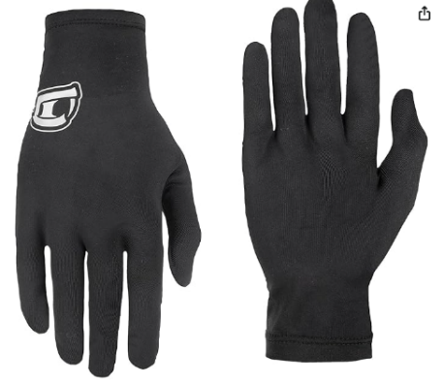
    - 2 pairs of liner gloves as wicking layer

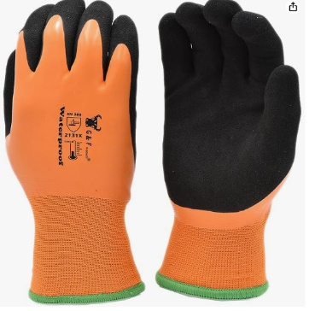
    - 1 pair of chemical/waterproof gloves as shell. I recommend: G & F Products Waterproof cold weather Double Coated Windproof HPT Plam and Fingers Acrylic Terry inner

  - Feet:
    - Socks: 2 pairs synthetic liner socks,
    - 2 pairs wool or heavy synthetic socks,
    - Waterproof snow boots/rubber boots with removable liners. YOU CAN RENT SNOW BOOTS AT SPORTS BASEMENT.
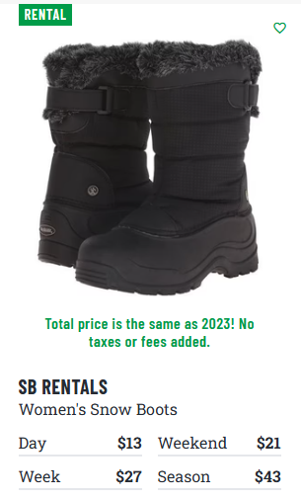

  - Gaiters (cover the gap between pants and boots): Very important!
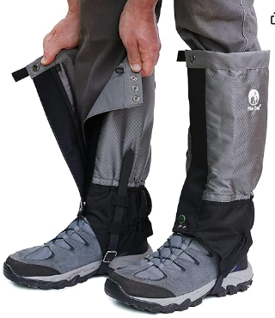

  - Sleeping Bag: No restrictions inside the heated cabin, preferably temperature rating of 20 or below.
  - Sleeping pad (with good insulation from ground)
  - Plastic Cup, bowl and spoon
  - Toiletry articles (toothbrush, toothpaste, etc.)
  - Headlamp or flashlight and extra batteries
  - Sunscreen (SPF 30 or higher) and lip balm
  - Hand and toe warmers
  - Toilet paper (Just few sheets, does not need to be a roll)
  - Personal snacks to keep you energized: energy bars, jerky and nuts. Nothings like gels that might freeze
  - Water bottle with insulated/vacuum layer (2+ liters per person per day)
  - GOOD TO HAVE: Hot Hands hand warmers.

- Scouts can borrow / rent / buy snowshoes & poles from one of the following venders.

YOU CAN BUY THE SHOES AT COSTCO FOR THE SAME PRICE AS RENTING AT SPORTSBASEMENT!

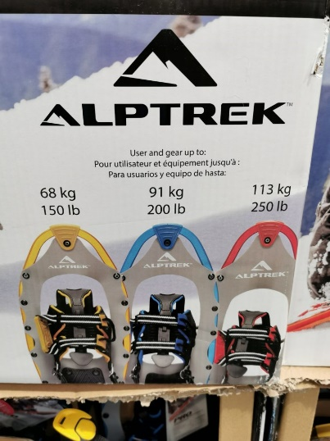

  - San Ramon - Sports Basement ($49)
https://shop.sportsbasement.com/products/sbrents-rental-snowshoes
  - Costco sells 3 sizes of snow shoes which are usually on sale for $40 after the holidays.
  - You can also borrow shoes from scouts who previously snow camped.

Location
- Snow activities will be held at Hwy 108 Sno-Park. It’s off CA Highway 108 east of Strawberry (https://ohv.parks.ca.gov/?page_id=23051 GPS: 38°16’1.47”N, 119°59’30.31”W). At an elevation of 5,800 feet above sea level in the Stanislaus National Forest, it’s about a 2 hour 41 minute non-stop drive from Danville.
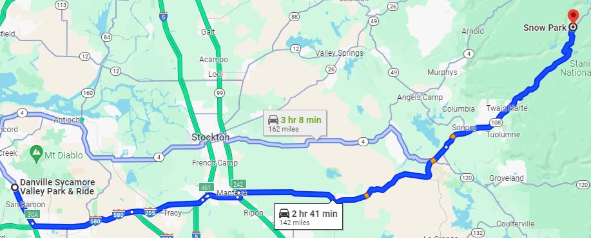
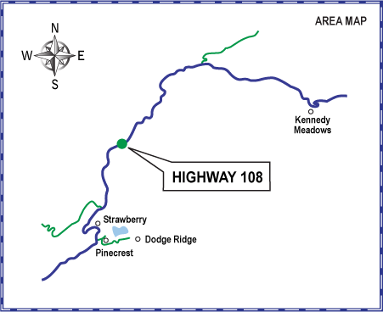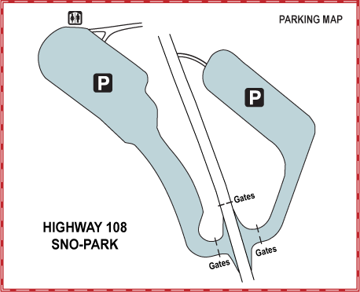

- Overnight accommodation: Camp Hi-Sierra Boy Scout Camp at 29211 CA-108, Long Barn, CA 95335. We have rented 3 cabins, each sleeping 8 in bunk beds. One cabin will be used for the adults and the other 2 for scouts. Cabins have power and heat. At an elevation of 5,000 feet, it’s about 26 minutes downhill from the Hwy 108 Sno-Park.
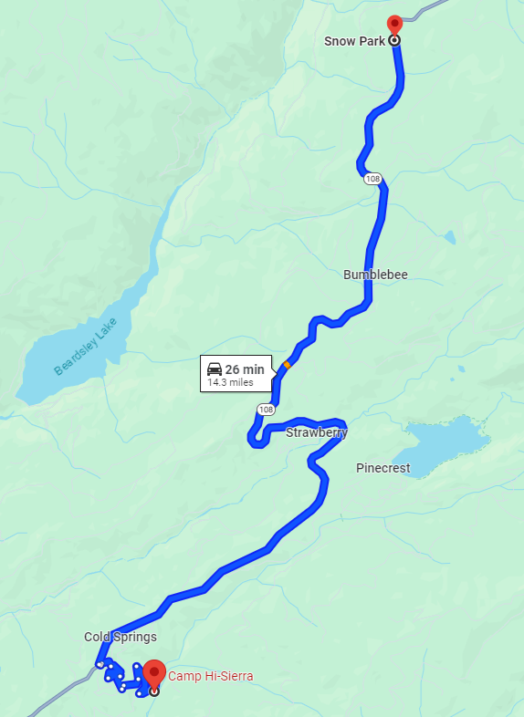

Schedule
- Activity Schedule
Friday 4:30 - 20:00 | Meet Dougherty Valley High School Parking Lot and travel to Camp High Sierra
Saturday 07:00 - 08:30 | Prepare, eat and clean up Breakfast at CHS
Saturday 09:00 – 9:30 | Travel to Hwy 108 Sno-Park
Saturday 10:00 – 12:00 | Explore and set up snow kitchen to cook hot and simple lunch
Saturday 12:00 – 16:00 | Group rotation to two snow shelter building stations
Saturday 16:00 – 17:00 | Dismantle snow shelters and travel to cabins
Saturday 17:00 – 19:00 | Prepare, eat and clean up Dinner at CHS
Saturday 19:00 – 20:00 | Roundtable group discussion on lessons learned
Saturday 21:00 | Lights out
 | Sweet dreams
Sunday 07:00 – 08:30 | Prepare, eat and clean up Breakfast at CHS
Sunday 10:00 – 14:00 | Depart. Travel to Dougherty Valley High School Parking Lot
- Introduction Stations (Each station is manned by at least an adult)
- Building of snow bricks and snow trench shelters ()
- Building of snow caves ()
- Winter hazards and survival skills ()
- Trip Planning and Preparation
  - 1/18/25 Meeting: Discussion of itinerary details, demonstration of gear, Q&A.
  - 1/11/25 Optional OA Winter Camping Awareness training, USS Hornet - Separate Signup on Troop Master
  - 2/4/25 Mandatory Meeting: Inspection of personal and group gear. Meal Planning.
  - 2/11/25 Meeting: Discuss pre-trip weather and logistics.
- Meal Plan (Planned by participating OSPL and scouts)
Friday Dinner
Bring sack meal to eat in the car or at Camp Hi Sierra.
Saturday breakfast (Included in the payment)
TBD by the scouts
Saturday lunch (Scouts to Bring)
We want to simulate the Intermediate Snow Camping's dining by boiling hot water on white gas stoves, and pour it in 2-serving packs of dehydrated food, with a long list flavors by Mountain House and Backpackers Pantry available at REI Dublin, considering food allergies.
Saturday Dinner (Included in the payment)
Pizza!
Sunday Breakfast (Included in the payment)
TBD by the scouts
Sunday Lunch
Scouts should bring $10-$20 in case we stop for lunch on the way home.

Cost
- Cost $130 which include 2 nights, cabin, pizza dinner Saturday, breakfast Saturday, lunch Saturday and breakfast Sunday.

Backup and Emergency Plan
- Too much snow? Weather forecasts at Cold Springs (Near Camp Hi Sierra) will be closely monitored for two weeks prior to outing. If the weather forecast is not suitable and the cabin is still available, the outing will be rescheduled to a later weekend.
https://weather.com/weather/radar/interactive/l/6680422023293f11efda16f2fe889640452a952086628a8732da06e5ba50ffe6
Snow depth map:
https://www.meteoblue.com/en/weather/maps/lake-alpine_united-states_5364404#map=snowDepth~hourly~auto~sfc~pressure2mOverlay&coords=11.13/38.2658/-119.9907
https://www.fs.usda.gov/Internet/FSE_DOCUMENTS/fseprd1045012.html

- Too little snow? Not much we can do. This snow park is at the top of the pass.

- The closest medical facility is Adventist Health Sonora at 1000 Greenley Rd, Sonora, CA 95370. It’s about 45 minutes of driving from Hwy 108 Sno-Park. Phone number: (209) 536-5000

- Camp High Sierra Ranger: Eric.Brewer@scouting.org

- Emergency contact: Stephanie Kuzmickas (925) 895-6079

- Stanislaus National Forest Phone: (209) 532-3671

References
- https://filestore.scouting.org/filestore/NorthernTier/pdf/2018_19_Winter/2018_2019_OKPIK_ADVISOR_PLANNING_GUIDE.pdf
- https://scoutingmagazine.org/2012/10/heat-up-winter-camping-with-tips-from-northern-tiers-okpik-training/
- https://scoutingevent.com/attachment/BSA296/1110_1381776261_1405.pdf

